**Electronic Code door locking system using PIC Microcontroller**

**Introduction:**

Science and technology have advanced our life in many ways. It facilitates the process of industrialization as well as modernization of the world. It has blessed us with many sophisticated devices by facilitating our life. Password based locking system is one of the modern electronic lock system. To ensure security many electronic lock have been introduced. Electric locks use magnets, solenoids, or motors to actuate the lock by either supplying or removing power. Operating the lock can be as simple as using a switch. The actuating mechanism of electronic lock is carried out by the application or by the removing of power. Some research works on electronic lock have been focused that will reveal the significance of the proposed system. In this project an electronic embedded lock has been designed that provides a great benefit over a traditional lock that uses only a manual key. This proposed lock comprises of a keypad and an LCD along with microcontroller. This lock can be used in many fields of practical life. For example, in door locking at homes, banks, offices, industries and other restricted areas for security purpose.

**Block Diagram:**

4x4 Keypad

PIC16F877A

LCD For showing entered code

Motor drive

Motor

Status Leds

Buzzer

**Objective:**

The objective of the project is to increase the security of any system any house, industry or any other thing. If a company or any organization only wants the entry of only authorized person at specific place than this system can be installed. Similarly in banks in some rooms the entry of only authorized people can be granted and irrelevant personalities can be restricted by this project. In last but not least this system can be installed successfully at homes.

**Circuit Diagram:**

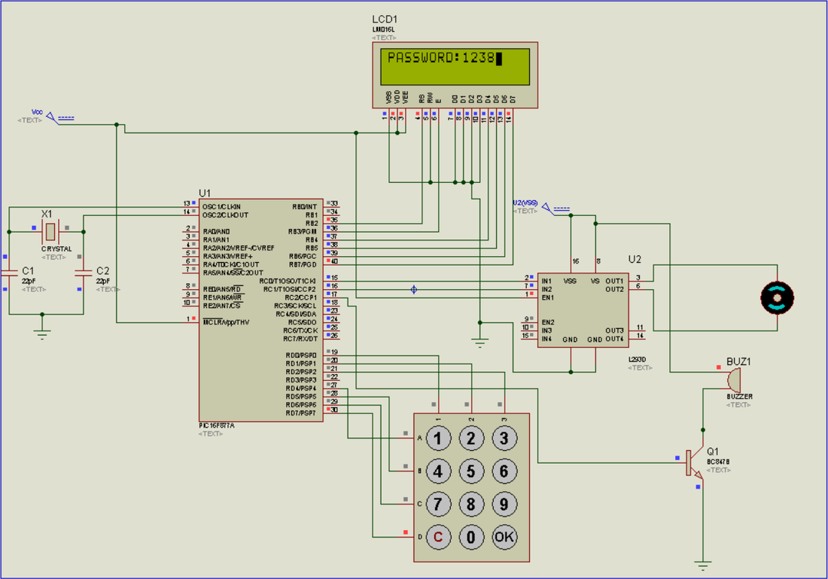

## **Overall Working:**

First of all when you connect power supply then microcontroller and LCD is in working state now. Microcontroller will initialize LCD on port B and keypad on Port D and set port C to output. Now everything is ready and when keypad button is pressed microcontroller will reads value and save this value in array and convert key value to its ASCII to display it on LCD. Its four digit password after entering four digits press OK button then  its will compares the saved password and user entered password after that there are two possibilities.  
**1-Password Correct:**  
If both strings matches then it will send signal to relay and relay will open the door via running motor clockwise. And then it asks to close the door by pressing digit one.

**2-Password Incorrect:**  
 If password is incorrect it will halt user and beeps buzzer and decrements ''No of attempts'' by one. If no of attempt is less than 0 it will block the user to enter password.

**Main components:**

* PIC16f877a
* 16x2 LCD
* 4x4 Keypad
* L298 motor drive
* DC Motor
* LEDs
* Buzzer

**PIC16F877A Controller:**

The PIC microcontroller **PIC16f877a** is one of the most renowned microcontrollers in the industry. This microcontroller is very convenient to use, the coding or programming of this controller is also easier. One of the main advantages is that it can be write-erase as many times as possible because it uses **FLASH memory technology.** It has a total number of 40 pins and there are 33 pins for input and output. PIC16F877A is used in many [pic microcontroller projects](https://microcontrollerslab.com/pic-microcontroller-projects-for-eee-students/). PIC16F877A also have much application in digital [electronics circuits](https://microcontrollerslab.com/electronics-projects/).

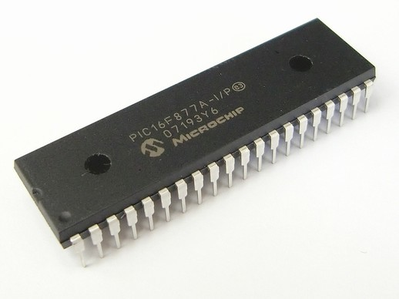

PIC16f877a finds its applications in a huge number of devices. It is used in remote sensors, security and safety devices, home automation and many industrial instruments. An[EEPROM](https://microcontrollerslab.com/eeprom-working-interfacing-with-microcontroller/) is also featured in it which makes it possible to store some of the information permanently like transmitter codes and receiver frequencies and some other related data. The cost of this controller is low and its handling is also easy. It is flexible and can be used in areas where microcontrollers have never been used before as in microprocessor applications and timer functions etc.

* It has a smaller 35 instructions set.
* It can operate up to20MHz frequency.
* The operating voltage is between 4.2 volts to 5.5 volts. If you provide it voltage more than 5.5 volts, it may get damaged permanently.
* It does not have an internal oscillator like other [PIC18F46K22](https://microcontrollerslab.com/pic18f46k22-microcontroller-introduction/), [PIC18F4550](https://microcontrollerslab.com/introduction-pic18f4550-microcontroller/).
* The maximum current each PORT can sink or source is around 100mA. Therefore, the current limit for each GPIO pin of PIC16F877A is 10 mili ampere.

**Contribution in Project:**

This component is the heart of the circuit. All the input output processes,driving motor and relay ,getting input fron keypad,verifying the password,shownig on LCD and many other things are done by this controller.

**4x4 Keypad Module:**

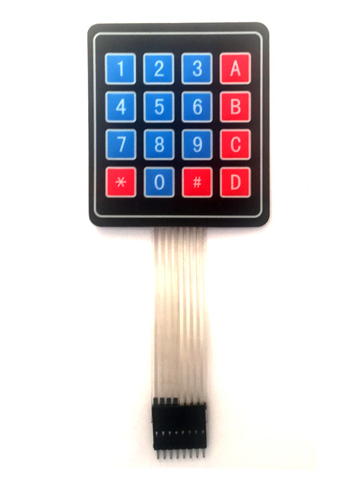

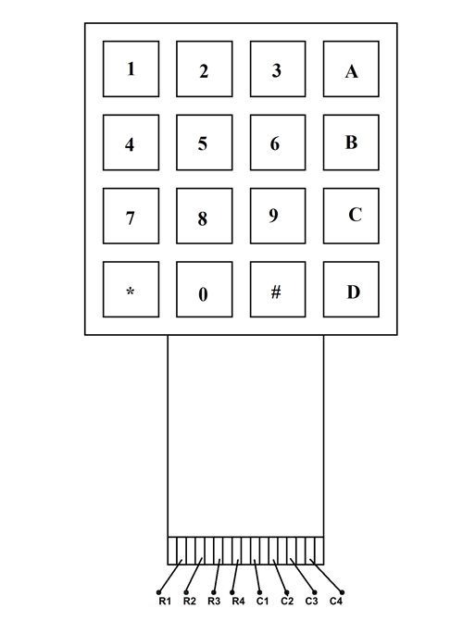

**4X4 KEYPAD Pin Configuration:**

4X4 KEYPAD MODULES are available in different sizes and shapes. But they all have same pin configuration. It is easy to make 4X4 KEYPAD by arranging 16 buttons in matrix formation by yourself.

|  |  |
| --- | --- |
| **Pin Number** | **Description** |
| **ROWS** | |
| 1 | PIN1 is taken out from 1st  ROW |
| 2 | PIN2 is taken out from 2nd  ROW |
| 3 | PIN3 is taken out from 3rd  ROW |
| 4 | PIN4 is taken out from  4th ROW |
| **COLUMN** | |
| 5 | PIN5 is taken out from 1st  COLUMN |
| 6 | PIN6 is taken out from 2nd  COLUMN |
| 7 | PIN7 is taken out from 3rd  COLUMN |
| 8 | PIN8 is taken out from 4th COLUMN |

As given in above table a 4X4 Keypad will have eight terminals. In them four are Rows of matrix and four are columns of matrix. These 8 PINS are driven out from 16 buttons present in the MODULE. Those 16 alphanumeric digits on the MODULE surface are the 16 buttons arranged in MATRIX formation.

**Contribution in Project:**

The keypad will be used as the input source for entering password to open the door.After getting password it gives this to the controller for processing and checking either entered password is right or wrong.

## **16×2 LED:**

The term [LCD stands for liquid crystal display](https://www.elprocus.com/difference-alphanumeric-display-and-customized-lcd/). It is one kind of electronic display module used in an extensive range of applications like various circuits & devices like mobile phones, calculators, computers, TV sets, etc. These displays are mainly preferred for multi-segment [light-emitting diodes](https://www.elprocus.com/light-emitting-diode-led-working-application/) and seven segments. The main benefits of using this module are inexpensive; simply programmable, animations, and there are no limitations for displaying custom characters, special and even animations, etc.

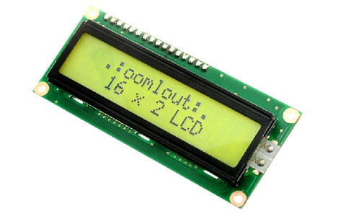

### **LCD 16×2 Pin Diagram:**

The 16×2 LCD pinout is shown below.

* Pin1 (Ground/Source Pin): This is a GND pin of display, used to connect the GND terminal of the microcontroller unit or power source.
* Pin2 (VCC/Source Pin): This is the voltage supply pin of the display, used to connect the supply pin of the power source.
* Pin3 (V0/VEE/Control Pin): This pin regulates the difference of the display, used to connect a changeable POT that can supply 0 to 5V.
* Pin4 (Register Select/Control Pin): This pin toggles among command or data register, used to connect a microcontroller unit pin and obtains either 0 or 1(0 = data mode, and 1 = command mode).
* Pin5 (Read/Write/Control Pin): This pin toggles the display among the read or writes operation, and it is connected to a microcontroller unit pin to get either 0 or 1 (0 = Write Operation, and 1 = Read Operation).
* Pin 6 (Enable/Control Pin): This pin should be held high to execute Read/Write process, and it is connected to the microcontroller unit & constantly held high.
* Pins 7-14 (Data Pins): These pins are used to send data to the display. These pins are connected in two-wire modes like 4-wire mode and 8-wire mode. In 4-wire mode, only four pins are connected to the microcontroller unit like 0 to 3, whereas in 8-wire mode, 8-pins are connected to microcontroller unit like 0 to 7.
* Pin15 (+ve pin of the LED): This pin is connected to +5V
* Pin 16 (-ve pin of the LED): This pin is connected to GND.

**Contribution in Project:**

Lcd is used in this project as showing the password entered either it is right or wrong.Also it shows the status of door either it is open or close and it also shows the number of attempts remaing.

## 

# DC Motor and [L293D](https://electrosome.com/l293d-quadruple-half-h-dc-motor-driver/):

We can’t drive a DC Motor (depends) directly with a Microcontroller, as DC Motors requires high current and high voltage than a Microcontroller can handle. Microcontrollers usually operates at +5 or +3.3V supply and it I/O pin can provide only up to 25mA current. Commonly used DC Motors requires 12V supply and 300mA current, moreover interfacing DC Motors directly with Microcontrollers may affect the working of Microcontroller due to the Back EMF of the DC Motor. Thus it is clear that, it not a good idea to interface DC Motor directly with Microcontrollers. The solution to above problems is to use H-bridge circuit.

[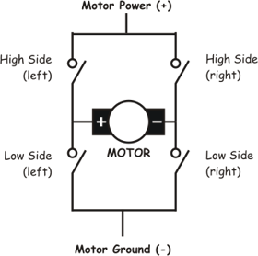](https://electrosome.com/wp-content/uploads/2012/06/basic-bridge.gif)

It is a special circuit, by using the 4 switches we can control the direction of DC Motor. Depending upon our power requirements we can make our own H-bridge using Transistors/MOSFETs as switches. It is better to use ready made ICs, instead of making our own H-bridge.L293D and [L293](https://electrosome.com/l293d-quadruple-half-h-dc-motor-driver/) are two such ICs. These are dual H-bridge motor drivers, ie by using one IC we can control two DC Motors in both clock wise and counter clockwise directions. The L293D can provide bidirectional drive currents of up to 600-mA at voltages from 4.5 V to 36 V while [L293](https://electrosome.com/l293d-quadruple-half-h-dc-motor-driver/) can provide up to 1A at same voltages. Both ICs are designed to drive inductive loads such as dc motors, bipolar stepping motors, relays and solenoids as well as other high-current or high-voltage loads in positive-supply applications. All inputs of these ICs are TTL compatible and output clamp diodes for inductive transient suppression are also provided internally. These diodes protect our circuit from the Back EMF of DC Motor.

[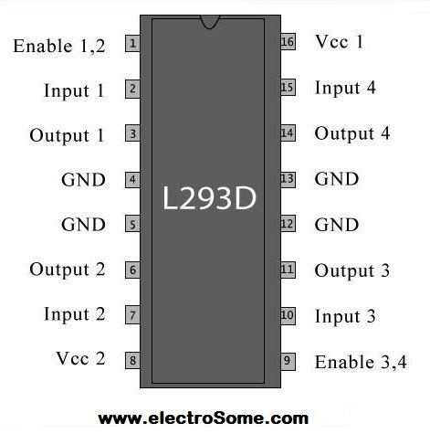](https://electrosome.com/wp-content/uploads/2012/06/L293D-pin-out.jpg)

In both ICs, drivers are enabled in pairs, with drivers 1 and 2 are enabled by a high input to 1,2EN and drivers 3 and 4 are enabled by a high input to 3,4EN. When drivers are enabled, their outputs will be active and in phase with their inputs. When drivers are disabled, their outputs will be off and will be in the high-impedance state.

**Contribution in Project:**

Motor drive and motor are essential part of this circuit. The motor is used to open and close the door.If we want to open the door the motor moves clockwise.And if we want to close the door the motor moves anticlockwise.

​

​